**FINAL REPORT**

**Himanshi Manglunia Kalpita Raut Laura Walker**

**DATASET & LICENSE:**

This project provides data to help students & families compare college costs & outcomes as they weigh the tradeoffs of different colleges, accounting for their own needs & educational goals.

Dataset can be found [here](https://collegescorecard.ed.gov/data/documentation/).

**TARGET AUDIENCE:**

* Prospective international students hoping to come to the United States to study
* Media companies like US News that publish rankings & analysis for the public
* Admissions staff at universities.

**TARGET RESEARCH QUESTIONS TO BE ANSWERED**

How does University of Maryl& compare with the other BIG TEN institutions based on :

1. Debt/Earnings
2. Repayment Rates
3. Completion Rates

**DATA PREPARATION & CLEANING**

We combined the data from College Scorecards & IPEDS into a single dataset. Since certain variables were categorized on the basis of year & gender, we appended columns- year & gender for easy analysis. There were missing values which were removed.

**PLOTS & INTERPRETATION:**

The red circle on these plots indicate University of Maryland & College Park

*DEBT CATEGORY:*

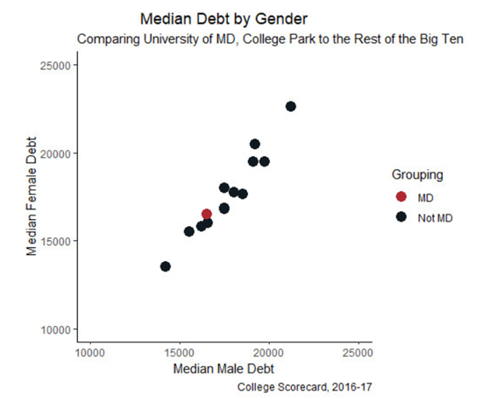

**Figure 1:** This plot describes the median debt of male & female students in the other Big Ten institutions as compared with UMD from 2016-2017. We observe a linear relationship between male & female & the average UMD debt is around $15,000.

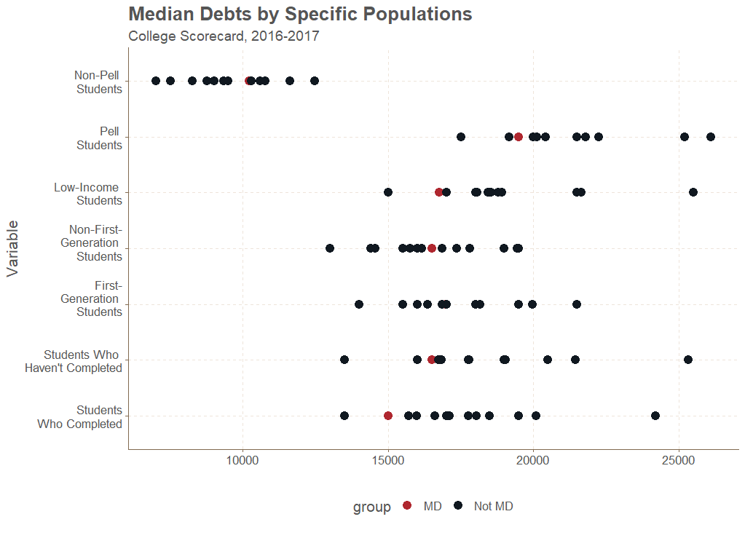

**Figure 2:** This plot depicts the median debt for various populations of students for 2016-2017. As observed, UMD debt for all categories is to the left-end i.e its lower as compared with other institutions.

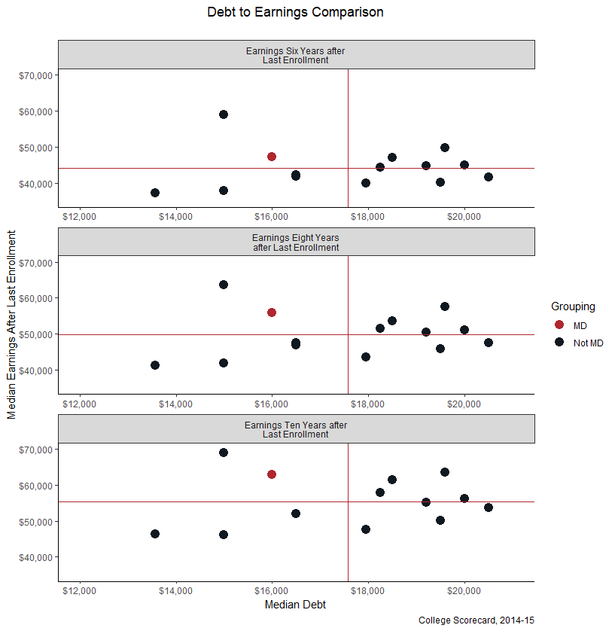

**Figure 3:** This plot compares the level of debt of students six, eight & ten years after their last semester to their earnings. The vertical red line in this plot represents where the Big Ten average debt is for the x-axis & the horizontal red line shows the average earnings in the y-axis. The earnings is above the mean & the debt is below the mean for UMD.

1. *REPAYMENT CATEGORY:*

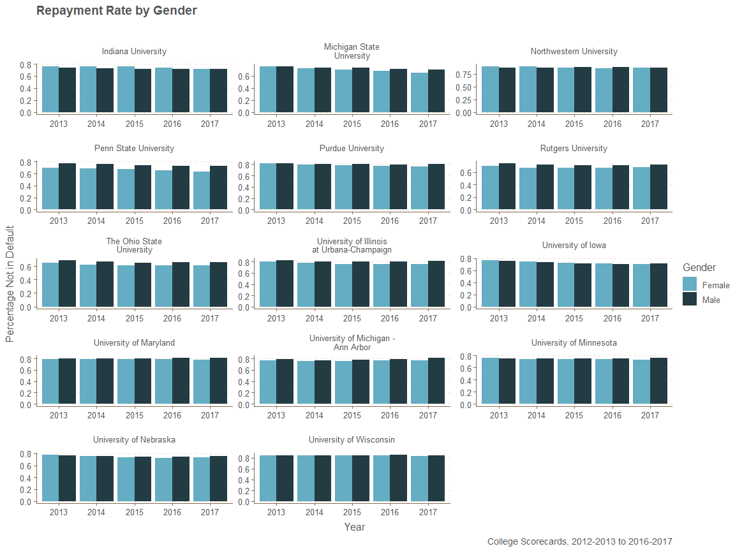

**Figure 4:** This plot shows the distribution of percentage of students who are not in default on the y axis against Male & Females for all the Big Ten institutions for 2013 to 2017. We observe that the percentages for female & male remain consistent for UMD.

*COMPLETIONS CATEGORY:*

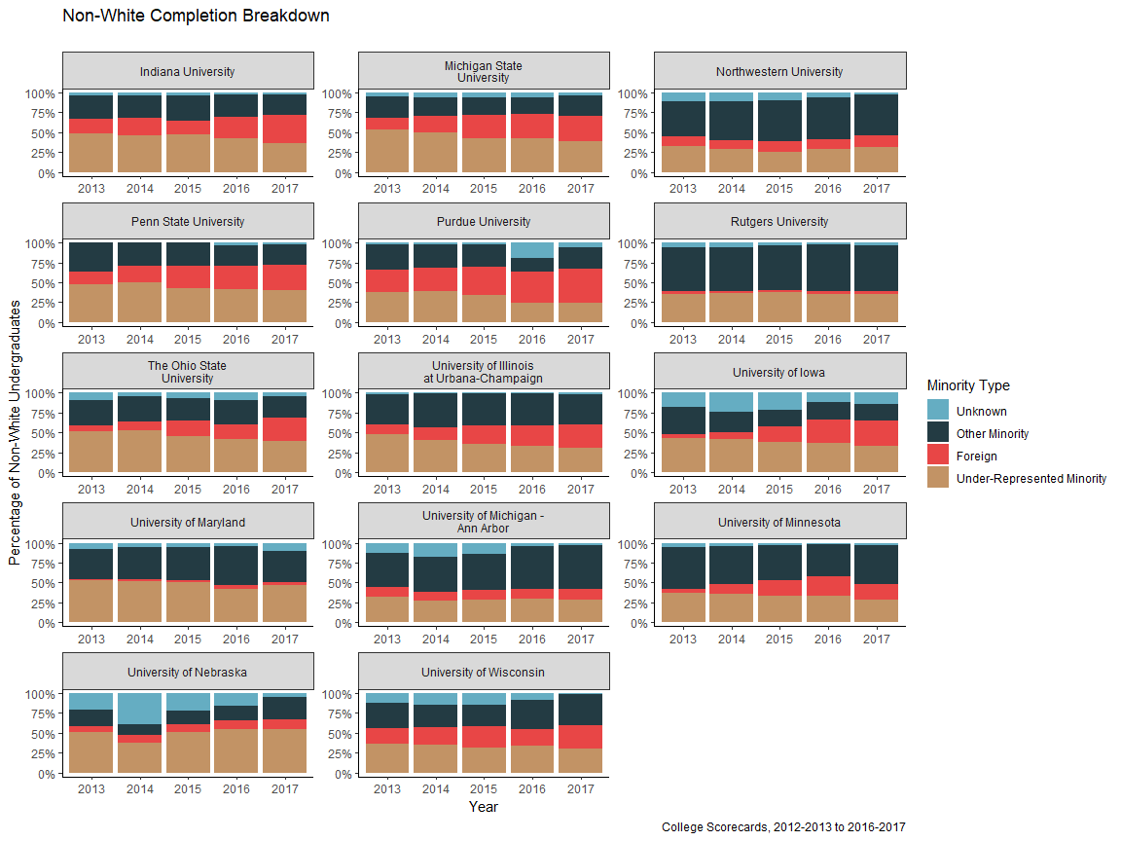

**Figure 5 :** In this plot, it can be observed that there is a slight decrease in the completion rate for under-represented minorities nationally but for UMD it remains pretty consistent.

**DECISION TO BE MADE**

* Students feel that UMD is an expensive school, & they may not be able to afford it, so they think twice before applying.
* But as we can see from our analysis

1. The repayment rate is highest among the Big ten.

2. Debt to Earnings ratio is low, which means the students pay their debt using their earnings in full.

3. Completion rates high when compared to Big ten.

* Through this analysis we can say that the ROI for UMD is high, & hence the students can consider.

**REFERENCES**

* <https://blog.prepscholar.com/big-10-schools>
* <https://nycdatascience.com/blog/student-works/college-scorecard/>